Table of Contents

PURPOSE
SCOPE
REFERENCES
TERMS, DEFINITIONS, ABBREVIATIONS, AND ACRONYMS
DISCLAIMER
Intent Of Guidelines
Guidelines Are Not
PLANT MODEL
S-FUNCTIONS

PURPOSE
This document describes the transient electro-mechanical models for 3-Phase Induction Motor and how to apply them in various simulation environments.

SCOPE
This library includes global models of 3-Phase Induction Motor .The application can be in Vertical or Horizontal Axis washers motor control algorithm development in MIL, SIL, PIL or HIL implementation.

REFERENCES

TERMS, DEFINITIONS, ABBREVIATIONS, AND ACRONYMS

TERM | DEFINITION
VA | Vertical axis washer
HA | Horizontal axis washer
CIM | Induction Motor
MIL | Model In Loop
SIL | Software In Loop
PIL | Processor in Loop
HIL | Hardware in Loop

DISCLAIMER
The information in this document contains recommendations based on best practices available and have been proven to some extent in different products. Challenging these recommendations is possible, but some risk may be there and should be evaluated carefully.

Intent of Guidelines
Guidelines are intended to be living documents that improve over time based on a compilation of experiences. The document is concise and explains best practices, practices that should be avoided, and other points worth noting. Guidelines are an enabler of global cross-product knowledge sharing which can be useful for new, as well as highly experienced, employees

Guidelines Are Not
Guidelines are not a replacement for engineering rigor nor do they override consumer/regional requirements. Guidelines are not requirements and are therefore not specifications.

PLANT MODEL
Plant model for CIM has following aspects:

Model Inputs:

Input | Description | Unit
iVa | Motor instantaneous Line (A-B) voltage | V
iVb | Motor instantaneous Line (B-C) voltage | V
iVc | Motor instantaneous Line (C-A) voltage | V
iTs | Temperature of the Stator Windings | Deg C
iTr | Temperature of the Rotor Cage | Deg C
iT_Dyno | Load Torque From Dyno Load | N.m

Model Outputs:

Output | Description | Unit
ia | Motor Instantaneous Phase Current(Phase-A) | A
ib | Motor Instantaneous Phase Current(Phase-B) | A
ic | Motor Instantaneous Phase Current(Phase-C) | A
oIrms_line | Motor RMS Current(RMS of 3-Phases) | A
oSpeed | Motor Shaft Speed | rad/sec
oSpeed_RotFlux | Rotor Magnetic Flux Speed | rad/sec
oPosition_RotFlux | Rotor Magnetic Flux Position | rad
oPmotor | Total Motor Power | W
oQbearings | Power dissipated in bearings | W
oQsteel | Power dissipated in iron core | W
oPshaft | Shaft Power delivered by Motor | W
oTshaft | Shaft Torque delivered by Motor | N.m

Model Parameters:

Parameter | Description | Unit
Rs | Per Phase Resistance of Stator Windings | Ohm
Rr | Per Phase Resistance of Rotor Bars | Ohm
Ls | Per Phase Self Inductance of Stator Windings | Henry
Lr | Per Phase Self Inductance of Rotor Bars | Henry
Lm | Magnetizing Inductance | Henry
p | Number of Pole Pairs | -
TsRef | Reference Temperature for Stator Resistance | Deg C
TrRef | Reference Temperature of Rotor Resistance | Deg C
Jrotor | Moment of Inertia of Rotor | Kg.m^2
Jadd | Additional Inertia in Motor | Kg.m^2
alpha_s | Temperature coefficient of Stator Winding Resistance | /K
Parameter | Description | Unit
conn | Flag for Stator Winding Configuration. (1- Star,3- Delta) | -
f_offset_rotlosses | Offset on rotational losses based on a baseline that is implemented in the model (Hefei 8Kg) ex: 1.0 - losses are similar to Hefei 8Kg CIM - 0.5: losses are 50% of Hefei 8Kg | -
f_rot_losses | Split of rotational losses in between steel losses and bearing / friction losses - this is important for the thermal Model.  1 - all losses go to steel;  0 - all losses go to bearing;  0.8 - 80% of rotational losses goes to steel, 20% goes to bearing (guess based on literature) | -
Mech_Flag | Flag to Select Model Variant for Mechanical Load.  0: HA Spin Model -1: Dyno Load Torque Model. | -

Plant Model Formulations

CIM electromechanical transient plant model is developed in Dymola environment

Model Based on Dynamic Equations

- Model is developed with the help of standard electromechanical equations. From Stator phase voltage inputs stator and rotor windings currents are solved using standard Kirchhoff’s Voltage Law equations. Motor electromagnetic torque is calculated from motor currents using standard relation. Newton’s second law of rotational dynamics is used to calculate motor shaft torque and speed.
- Stator and rotor resistances are modeled as temperature dependant resistances based on stator and rotor winding temperatures. Steel and Rotational losses are modeled as empirical relations of motor speed and motor stator voltages. Model structure and dynamic equations are shown in figure below:

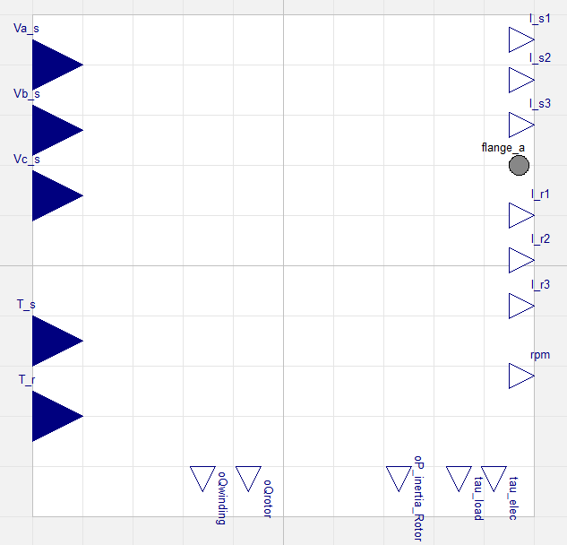

Figure 1: Base Model Using Dynamic Equations
` 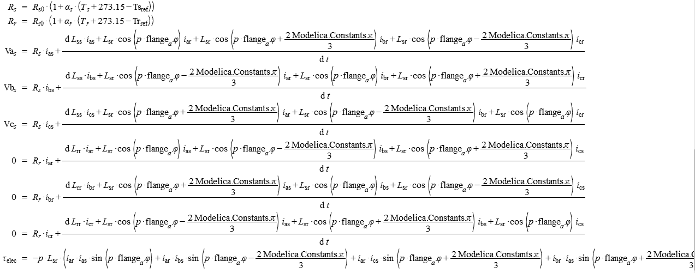
Figure 2: Electrical Dynamic Equations

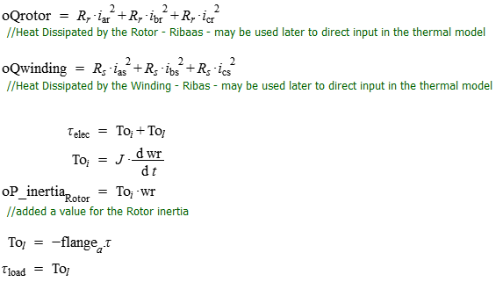
Figure 3: Equations for Mechanical Dynamics and Losses

Application in Simulation Architecture

In order to integrate the CIM electrical model with the Motor Control Transient Simulation architecture it is coupled with the basic model of HA Washer mechanics model as shown:

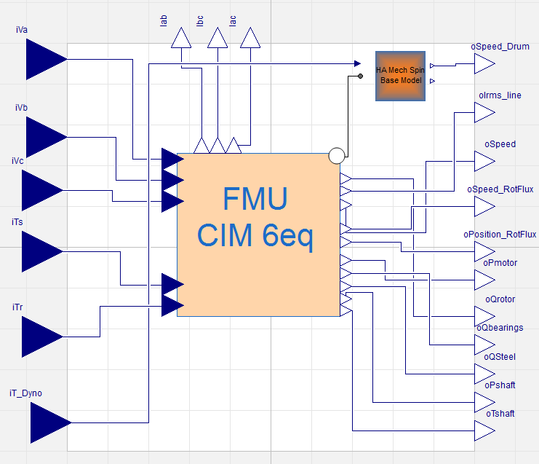
Figure 5 : CIM Model Coupled with Mechanical Model

:

Variants
In the file Parameters File, the parameters of each motor variant are presented.

CONTRIBUTORS
(Individuals who contributed to the content of this document)
NAME | USERID | NAME | USERID

REVISION HISTORY
REV | DESCRIPTION OF CHANGE | SECTION | BY | E. N. | DATE
A | DRAFT |  | KIRTACA |  | 26-OCT-2016

